Mira Costa High School: AP Art History Ms. Park
Name __________________________Period _____
Art History Quiz: Global Prehistory Date_______________ Score _________/ 60 pts.

Each question is worth 2 points. Short answer is worth 10 points.

1. Approximate date for Paleolithic art: ____________________
2. Approximate date for Neolithic art: ____________________
3. The Woman of Willendorf is from which time period? (Circle one) Paleolithic / Neolithic
4. The Ambum Stone is from which time period? (Circle one) Paleolithic / Neolithic
5. Stonehenge is from which time period? (Circle one) Paleolithic / Neolithic
6. The Anthropomorphic Stele is from which time period? (Circle one) Paleolithic / Neolithic
7. What does prehistory mean? __________________________________________________________________
8. What is a megalith? __________________________________________________________________________
9. What is terracotta? ___________________________________________________________________________
10. What is anthropomorphic? _____________________________________________________________________
11. Provide evidence within in one artwork that is described as anthropomorphic.
______________________________________________________________________________________________
______________________________________________________________________________________________

12. What does Paleolithic mean?
a. the word “Paleolithic come from Latin and means “a really long time ago”
b. the word “Paleolithic come from Hebrew word meaning “hard stone”
c. the word “Paleolithic come from Greek and means “old stone age”
d. the word “Paleolithic come from Arabic and means “before writing”

13. What is a lintel?
a. an upright beam b. a beam used to span an opening
c. a form of volcanic stone d. a type of marble

14. Artists working on prehistoric caves used all of the following tools to create their images EXCEPT
a. scaffolds to reach high areas in a cave b. paints made from ocher and natural materials c. brushes made from human hair d. flat stones used as palettes

15. Stylized animal forms appear in all of the following EXCEPT
a. Tlatlico Female Figurine b. Apollo 11 stones
c. The Ambum Stone d. camelid sacrum in the shape of a canine

16. Prehistoric images of people wearing masks, such as the Running Horned Woman, indicate an ancient interest in
a. coronation of royalty and a sophisticated power structure
b. a formal hierarchy of religious leaders, including women
c. ceremonial centers and designated performers
d. ritual presentations in which the participants paint their bodies and dance

17. Many prehistoric works were layered by successive generations of artists over the course of centuries. This is true
for all of the following works EXCEPT
a. Stonehenge b. Lascaux
c. Running Horned Woman d. camelid sacrum in the shape of a canine

18. All of the following prevents art historians from knowing the original meaning of the Woman of Willendorf EXCEPT?
a. Its historical context is unknown b. Its culture produced no known written records
c. The object lack visual details d. Interpretation can be clouded by modern biases

19. Of the following artworks, which was created first?
a. Jade cong b. Stonehenge c. Great Hall of the Bulls d. Beaker with Ibex motifs

20. What did the prehistoric paintings in European caves mean to the people who created them?
a. The paintings are evidence of a prehistoric religion b. The cave paintings are evidence of a political agenda c. They show how much people cared about animals d. We don’t know

21. The convention of representing animals’ horns in twisted perspective in cave paintings or allowing the viewer to see
the head in profile and the horns in the front is termed
a. descriptive b. fanciful c. optical d. true

22. The camelid sacrum in the shape of a canine is from which region?
a. Tequixquiac, Mexico b. Altamira, Spain c. Papua New Guinea d. Lapita

23. The people of the Pacific Ocean migrated from Asia approximately
a. 100,000 BCE b. 80,000 BCE c. 45,000 BCE d. 2000 BCE

24. Sculptural works from the Paleolithic era consist of all of the following EXCEPT
a. life-size sculptures of humans b. figurines c. beads d. decorative utilitarian objects

25. All of the following artworks have an example of a silhouette image EXCEPT?
a. Apollo 11 stones b. Ibex Beaker c. Terracotta fragments d. Hall of the Bulls

26. This jade cong was made in Neolithic China. It has a function that can be surmised from the site it is associated with.
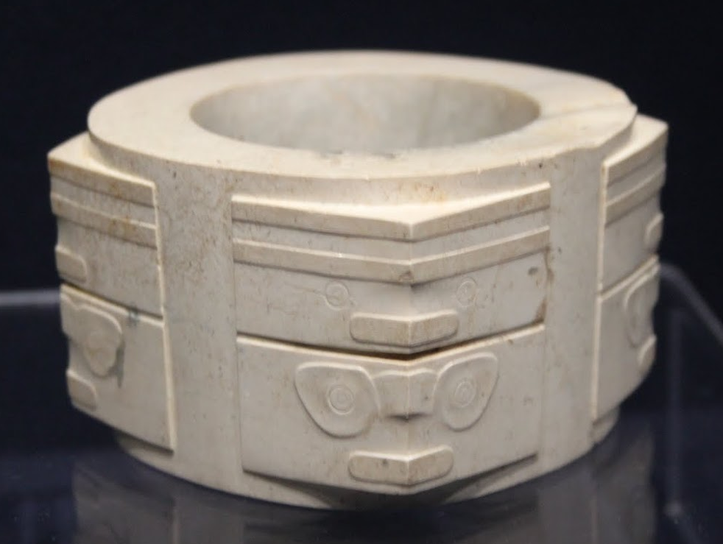

Where were jade congs found?
What can be understood about jade congs given their find spot?
Describe the images done in relief on the cong, and interpret their possible meanings.
(10 points)

_________________________________________________________________________________________________
____________________________________________________________________________________________________________________________________________________________________________________________________________________________________________________________________________________________________________________________________________________________________________________________________________________________________________________________________________________________________________________________________________________________________________________________________________________________________________________________________________________________________________________________________________________________________________________________________________________________________________________________________________________________________________________________________________________________________________________________________________________________________________________________________________________________________________________________________________________________________________________________________________

