Mira Costa High School: AP Art History Ms. Park
Name __________________________Period _____
Art History Quiz: The Pacific Date_______________ Score _________/ 64 pts.

Each question is worth 2 points. Short answer is worth 10 points.

1. Approximate date for Paleolithic art: ____________________
2. Approximate date for Neolithic art: ____________________
3. What are prismatic columns? ______________________________________________________________________
4. What is a tapa cloth? ____________________________________________________________________________
5. What was the purpose of tatau (tattoo)?
_________________________________________________________________________________________________
_________________________________________________________________________________________________
Bonus! Do you have a tattoo(s)? Tell me about it (or your favorite)! ___________________________________________
__________________________________________________________________________________________________________________________________________________________________________________________________

6. How was information transmitted from one generation to the next in Pacific Island societies?
a. verbally b. stone carvings
c. written manuscripts d. calligraphy carved on boards

7. In Pacific Island societies, mainly men were active in creating which of the following?
a. masks b. wood carvings
c. pottery d. tapestries

8. Malanggan refers both to the festivals to honor the deceased and which of the following?
a. yam masks b. storyboards
c. objects and carvings produced for these festivals d. ceremony of initiation

9. Which of the Polynesian groups is primarily responsible for the major art form of barkcloth making and decorating?
a. uninitiated boys b. men
c. uninitiated girls d. women

10. The weaving technique used to make tapa requires
a. a heating process whereby the fabric is covered with wax and the threads are melted in place b. the use of silk threads to be woven into a background of sheep’s wool
c. beating soaked strips of tree bark into a flat surface to be later woven into a cloth-like fabric d. stitching thread into a pre-made backing to form a design

11. Prehistoric works from the Pacific, such as the Ambum Stone, illustrate the ongoing tradition of using animal motifs
that appear in such works as
a. the Moai from Rapa Nui (Easter Island) b. Malagan masks
c. Buk masks d. the Female Deity from Nukuoro

12. Researchers have assigned Australia to be occupied at which date range?
a. 3000 + years b. 40,000 + years
c. 100,000 + years c. 150,000 + years

13. What is mana?
a. wealth in shell money b. strength in spiritual power
c. women’s power d. men’s power

For questions 14-15 refer to the image below.

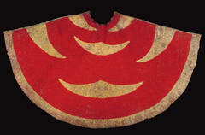

15. This garment belonged to
a. Hawai’ian royalty b. Motecuhzoma II
c. King MaMBul d. Coyolxauhqui
14. This type of garment is used in which of the following contexts?
a. It established a royal lineage by discrediting rivals to the throne
b. It linked the wearer to the gods
c. It made a connection between the human world and the animal world
d. It cast spells on enemies

16. What material/media is unique to the Buk (mask)?
a. I’iwi birds b. hawksbill sea turtles
c. spiney sea urchins d. endangered dugongs

17. In the portrait of Tamati Waka Nene an emphasis is placed on the symbols rank in the following ways EXCEPT
a. ta moko b. staff with an eye
c. feathers dangling from staff d. short cropped hair

18. Ta moko is the traditional New Zealand art of
a. painting b. sculpture
c. tattooing d. weaving

19. The island city of Nan Madol is the only city in existence to be built
a. on a coral reef b. at the base of an ancient volcano c. by still standing megalithic architecture d. on naturally occurring raised platforms

20. The staff god of the late 18th c is from
a. Papua New Guinea b. Marshall Islands c. The Cook Islands d. Hawai’i

21. Why was the staff god wrapped and what is it wrapped in? ______________________________________________
________________________________________________________________________________________________

22. Navigation charts were used by people of
a. Papua New Guinea b. Marshall Islands c. The Cook Islands d. Hawai’i

23. How are the ahu and moai of Easter Island related?
a. Moai are large stone statues depicting female figurines, while ahu depict male figurines.
b. Moai are stone platforms upon which stone ahu statues rest.
c. Ahu are large stone statues depicting female figurines whle ahu depict male figurines
d. Ahu are stone platforms upon which stone moai statues rest.
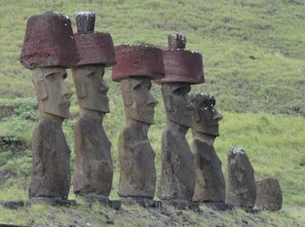

24. The image on the left are the Moai statues on a platform from c. 1100 on Easter Island.

What were the statues a representation probably of? How do we know?
What was the purpose of adding white coral to the eyes?
How does the image reflect the possible meaning and function?
(10 points) – answer on next page, please.
________________________________________________________________________________________________
_______________________________________________________________________________________________________________________________________________________________________________________________________________________________________________________________________________________________________________________________________________________________________________________________________________________________________________________________________________________________________________________________________________________________________________________________________________________________________________________________________________________________________________________________________________________________________________________________________________________________________________________________________________________________________________________________________________________________________________________________________________________________________________________________________________________________________________________________________________________________________________________________________________________________________________________________________________________________________________________________________________________________________________________________________________________________________________________________________________________________________________

Global Prehistory

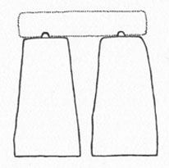
For questions 25-26 label the following parts.
26. _______________________
25. _______________________

27. The convention of representing animals’ horns in twisted perspective in cave paintings or allowing the viewer to see
the head in profile and the horns in the front is termed
a. descriptive b. fanciful c. optical d. true

28. The Woman of Willendorf is from which time period? (Circle one) Paleolithic / Neolithic

