Mira Costa High School: AP Art History Ms. Park
Name __________________________Period _____
Art History Quiz: Indigenous Americas Date_______________ Score _________/ 68 pts.

Each question is worth 2 points. Short answer is worth 10 points.

1. The placement of the relief of Coyolxauhqui was critical not only to Aztec religious observances but also to the
political persona of the Empire. Which of the following was the location of the relief?
a. It was placed on floor before the sanctuary.
b. It was placed at the bottom of the Templo Mayor’s stairs.
c. It was hung on the east wall of the sanctuary.
d. It was mounted at the top of the stairs to the Templo Mayor.

2. Why is Machu Picchu of great archaeological importance?
a. It was undisturbed since Inka times.
b. It was the most excavated site following its discovery in the late 1800s.
c. Its extensive written records detailed the city’s history as a private compound for the Inka.
d. The history of its conquest detailed its importance to the Inka.

3. Which of the following animals represented Chavín strength and power in art?
a. anaconda b. eagle
c. cheetah d. jaguar

4. Which of the following masks would be used during the Kwakiutl winter ceremonial season?
a. transformation mask b. wolverine mask
c. lion mask d. jaguar mask

5. Transformation masks are best understood as works
a. used as centerpieces in homes
b. that are seen as part of a larger ceremony
c. used to recall ancestral spirits to act on the wearer’s behalf
d. used as a display much the same way that totem poles are used.

6. A prime example of the dry-stone technique is found in which of the following?
a. Temple of Quetzalcoatl at Teotihuacán b. Maya Temple I at Tikal
c. Inca walls at Saqsa Waman d. Mesa Verde cliff dwellings

7. Native American artworks often show the influence of Europeans in that they
a. used European materials in their work
b. portrayed European historical events with their own histories
c. adapted European traditions and abandoned Native American imagery in their work d. experimented with European artistic techniques such as contrapposto and chiaroscuro

8. The Hide Painting of a Sun Dance draws on Native American traditions
a. in its use of the repousse technique
b. in that it shows great virtuosity in the handling of European forms
c. of articulating forms by placing them in an active sequence around a given space d. that place humans on an exaggerated scale dominating all other figures in a work

9. The Intihuantana stone at Machu Picchu was believed to be where
a. sacrifices were held
b. a sacred place of celebrating the equinoxes
c. the world’s first observatory was
d. rulers would perform rituals to appease the gods

10. At the Chavín de Huántar site, nose ornaments
a. were used for leading sacrificed people into the underworld
b. worn to show allegiance to the Chavín religion
c. were pierced in the wearer’s nose at the time of puberty
d. held protective religious powers

11. A comb roof could be found at the site of
a. Chavín de Huántar
b. Templo Mayor
c. Mesa Verde cliff dwellings
d. Yaxchilán

12. The relief of Lady Xoc (Lintel 25, Structure 23) at Yaxchilán shows all of the following EXCEPT
a. Lady Xoc in an intense hallucinogenic state
b. Shield Jaguar II’s (her husband) coronation crown
c. mirror image inscriptions to show her altered reality
d. Lady Xoc holding a bowl of bloodletting ceremonial tools

13. The Maize Cobs, created out of hammered metal sheets, can be found at
a. Chavín de Huántar
b. Qorikancha
c. Mesa Verde cliff dwellings
d. Yaxchilán

14. Which centuries was the Inkan Empire at its height?
a. 15th c. b. 14th c.
c. 13th c. d. 12th c.

15. What are the two types of beading techniques used on the bandolier bags? (1pt each)

a. _________________________________ b. _________________________________

16. What are Maria and Julian Martinez credited for? _____________________________________________________
_________________________________________________________________________________________________

17. What is an effigy mound? ________________________________________________________________________

For questions 18-23 select the best response.
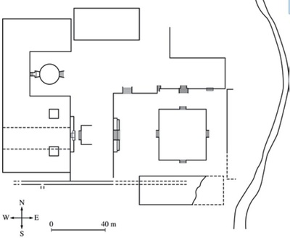
18. 19.
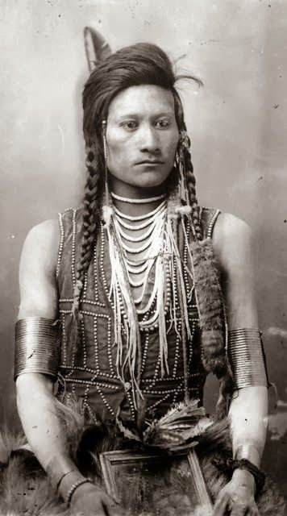
a. Julian Martinez a. Machu Picchu
b. Hiram Bingam b. Yaxchilán
c. Cadzi Cody c. Qorikancha
d. Monteczuma II d. Chavín de Huántar

20. 21.
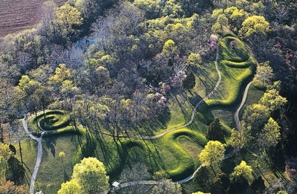
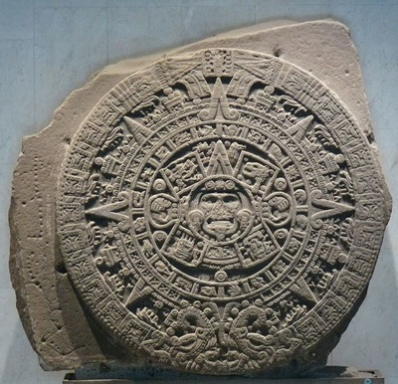

a. Ohio a. Mayan
b. Canada b. Incan
c. Colorado c. Aztec
d. Wyoming d. Anasazi

22. 23.
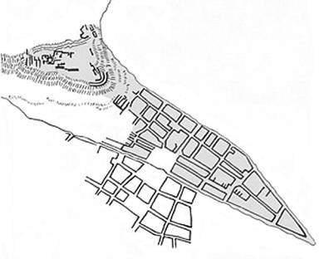
- Mayan
- Aztec
- Inkan
- Chavin
a. Ohio
b. Canada
c. Colorado
d. Wyoming

24. Which of the following statements regarding Machu Picchu is false?
a. The city was built using polished, dry-stone walls.
b. The city was carefully planned using a sophisticated drainage system.
c. The monument structure of the city echoed the natural environment.
d. The city of built for ceremonies with an emphasis on animals and precious stones.

25. (5pts) Discuss the All-T’oqapu tunic and what makes tunics like it valuable. To which cultural group does it belong to?
________________________________________________________________________________________________
____________________________________________________________________________________________________________________________________________________________________________________________________________________________________________________________________________________________________________________________________________________________________________________________________

26. (5pts) What is the cultural significance of the Aztec Calendar Stone?
________________________________________________________________________________________________
____________________________________________________________________________________________________________________________________________________________________________________________________________________________________________________________________________________________________________________________________________________________________________________________________
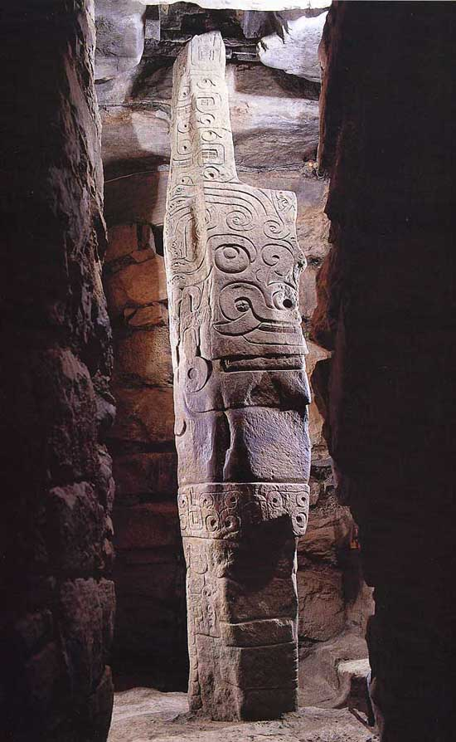
27. (10pts)
Identify this artwork and its original location.
Discuss the symbolism of its placement within its location.
What is depicted on the stela and how does this depiction reflect the meaning of the work?

_____________________________________________________________________
_____________________________________________________________________
_____________________________________________________________________
_____________________________________________________________________
_____________________________________________________________________
_____________________________________________________________________
_____________________________________________________________________
_____________________________________________________________________
_____________________________________________________________________________________________________________________________________________________________________________________________________________________________________________________________________________________________________________________________________________________________________________________________________________________________________________________________________________________________________
________________________________________________________________________________________________
_____________________________________________________________________________________________________________________________________________________________________________________________________________________________________________________________________________________________________________________________________________________________________________________________________________________________________________________________________________________________________
__________________________________________________________________________________________________________________________________________________________________________________________________

