Art History Quiz Ms. Park
Baroque
Name _______________________________
Date __________________ Period ______ Score _____/ pts

1. Date for the Neolithic time period: ______________________
2. Date for the Greek Severe time period: ______________________
3. Date for the Sumerian (Sumer) time period: ______________________
4. Time period of 1000 BCE: ___________________________________
5. Date for the Roman Republic time period: ____________________
6. Date for the Egyptian time period of the Old Kingdom: ______________________
7. Time period for 1100: ___________________________________
8. Date for the Egyptian time period of the New Kingdom: ______________________
9. Time period for 7th century: ___________________________________
10. Date for late Gothic architecture: _____________________
11. Date for the Greek Archaic time period: ______________________
12. Time period for 1900BCE: ___________________________________
13. Date for the High Renaissance period: _____________________
14. Time period for 800: ___________________________________
15. Time period for 25,000 BCE: __________________________________

16. Which of the following artists influenced the female artist Artemesia Gentileschi?
a. Vermeer b. Caravaggio
c. Bernini d. Rembrandt

17. the Hall of Mirrors is an example of which type of Baroque style?
a. Flemish Baroque b. German Baroque
c. Italian Baroque d. French Baroque

18. What was the main function of most Italian Baroque art?
a. to push people into seminaries and convents b. to provide a faithful return to the Catholic church
c. to instruct people to become Protestant c. to remind the middle class that they can purchase art

19. Which is the most characteristic feature of the Baroque style in general?
a. elongation and elegance b. violent (spiritual or actual) action
c. frontal figures d. flat spaces

20. Caravaggio’s Calling of Saint Matthew quotes visually from
a. the Gospel of Matthew b. Raphael’s School of Athens
c. Gauilli’s ceiling at Il Gesu d. Micheleangelo’s ceiling at the Sistine Chapel

21. Tenebrism refers to
a. chiaroscuro (values)
b. a dominance of cast shadows
c. sharply and exaggerated contrasts between light and dark
d. atmospheric perspective
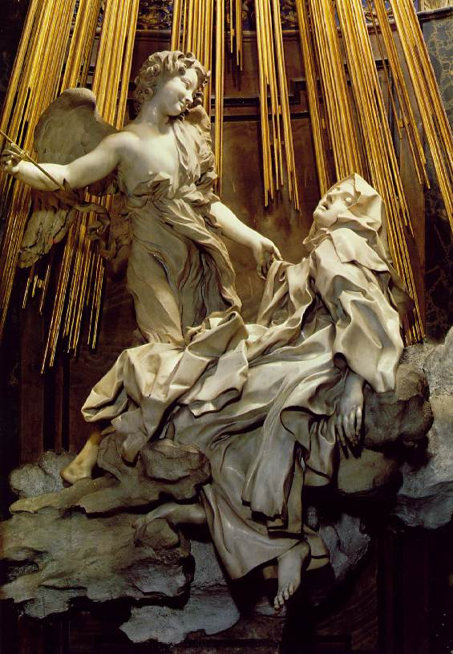
For questions 22-25, refer to Figure A
22. The sculpture of the work is by
a. Celini b. Caravaggio
c. Bernini d. Bellini

23. The subject of the work is
a. the Annunciation of the Virgin Mary b. the martyrdom of St. Catherine
c. a miracle of Saint Ursula d. a mystical experience of St. Teresa

24. The work is located in
a. Florence b. Rome
c. Padua d. Venice

Figure A

25. Which of the following is NOT true of Bernini’s Ecstasy of St. Teresa?
a. All of the marble was finished in the same way, unifying the figures with the architecture of the chapel
b. The subject is of a saint, canonized in 1622, having a vision of an angel. The artist based his sculpture on St. Teresa’s written accounts of the vision
c. Both the text and the artist’s sculpture use the physical body and sexual symbolism to convey the spiritual experience
d. The artist combines elements of architecture, sculpture, and painting in situating the sculpture in the chapel with polychromed marble, fresco, and stained glass.

26. Most of ________’s paintings are interior scenes, many with allegorical meaning.
a. Ruysch b. Rembrandt
c. Velazquez d. Vermeer

27. Which is LEAST likely to appear as a vanitas iconography?
a. a skull b. a windmill
c. a watch d. a candle

28. Velasquez’s Las Meninas is an unusual combination of
a. a genre (ordinary life) scene and royal portrait
b. portrait of the artist and a scene from literature
c. a royal portrait and biblical story
d. a history painting and genre scene

29. Which of the following interpretations is NOT reasonable for Vermeer’s Woman Holding a Balance?
a. The painting in the background frames the woman’s actions within a secular context.
b. The painting expresses a tension between wealth and piety.
c. The mirror is a symbol of the woman’s vanity but it could also be a symbol of self knowledge and truth.
d. In the balance that the woman holds, there is a sense of time and change.

30. Rembrandt was often interested in which aspect of the figures he painted?
a. their domestic duties b. their relationship to the natural or built environment
c. their internal state of mind d. their sense of social status

31. Short Answer: If you were to create your own vantitas still life, what objects would you include and why? What kind of insight would the viewer see of your life? What symbolism would the objects represent? How would you want to be remembered? (10 pts)

_________________________________________________________________________________________________
______________________________________________________________________________________________________________________________________________________________________________________________________________________________________________________________________________________________________________________________________________________________________________________________________________________________________________________________________________________________________________________________________________________________________________________________________________________________________________________________________________________________________________________________________________________________________________________________________________________________________________________________________________________________________________________________________________________________________________________________________________________________________________________________________________________________________________________________________________________________________________________________________________________________________________________________________________________________________________________________________________________________________________________________________________

