Mira Costa High School AP Art History Ms. Park
Name__________________________________________
*Art History Quiz: Gothic Architecture Date____________ Period______ Score /88 pts

Each correct answer is 2 points unless otherwise noted. Short answer is worth 5 points.

1. Approx. date of the Early Gothic time period: _____________ 2. Approx. date of the High Gothic time period: _____________
3. Approx. date of the Late Gothic time period: _____________ 4. Approx. date of the Minoan time period: _______________
5. Approx. date of the Ottonian period: _____________ 6. Approx. date of the Persian time period: _____________
7. Approx. date of the Roman Republic period: _____________ 8. Approx. date of the Romanesque time period: _____________
9. Which architecture is the first fully Gothic church? __________________________________________________________________________
10. What is the advantage of the pointed arch within Gothic architecture? _____________________________________________________
______________________________________________________________________________________________________________________________
11. How is the Gothic flying buttress different from that of the Romanesque buttress? ____________________________________________
_______________________________________________________________________________________________________________________________
12. Which of the following is a standard (consistent) of Gothic architecture?
a. rounded arches b. rose windows c. the ogee arch d. small windows

13. The portal sculptural program for Chartres Cathedral is distinctly different from its Romanesque counterparts. Which of the following accounts for this distinction?
a. the exclusion of scenes from the Passion b. the inclusion of the Old Testament Kings
c. the prominence of Mary in the portal program d. the inclusion of scenes from the life of Christ

14. Which of the following is considered a masterpiece of the Rayonnant style?
a. Reims Cathedral b. St. Denis c. Ste- Chapelle d. Amiens Cathedral

15. Fan vaulting is most commonly found in which period of Gothic architecture? _______________________________________________ 16. Abbot Suger is credited with completely renovating which Gothic architecture? Why did he do this? __________________________ _______________________________________________________________________________________________________________________________ _______________________________________________________________________________________________________________________________
17. What is the “squat screen” and give an example of architecture where this can be identified. _________________________________
_______________________________________________________________________________________________________________________________
18. What did a Gothic Cathedral symbolize? ___________________________________________________________________________________
_______________________________________________________________________________________________________________________________
19. What is lux nova? __________________________________________________________________________________________________________
20. What is the purpose of the triforium? _______________________________________________________________________________________

Identifications: Part 1

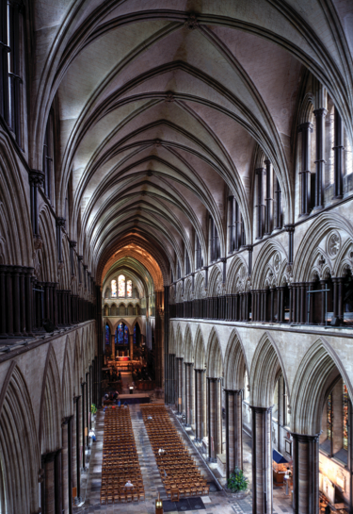

21. Identify _____________________________________

22. Circle one: This is a(n) Early / High / Late Gothic cathedral.

23. This cathedral is from what country? ____________________________________

24. Identify ____________________________________

25. To which cathedral does this belong? ______________________

26. This cathedral is from what country? __________________________

27. The sculptural program of this is from the Early / High / Late
Gothic period.

28. Briefly describe what is being depicted and its meaning in the tympanum. ___________________________________________________________________________ ___________________________________________________________________________
___________________________________________________________________________
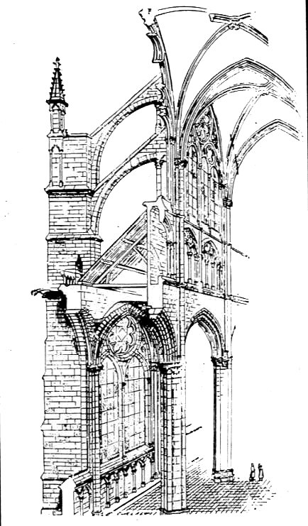

Clearly label all the parts of
the cathedral with the WORDS
in the word bank below. If it is any
way unclear where your
arrows are pointing to, I will
mark it wrong! (1 point each)

29. Triforium | 30. Capital | 31. Pier | 32. Base | 33. Shaft
34. Webbing | 35. Oculus | 36. Transverse arch | 37. Groin vault | 38. Pinnacle
39. Nave arcade | 40. Flying buttress | 41. Crocket | 42. Stringcourse | 43. Lancet

Slide Identifications: Part 2 (line a: identify, line b: identify the country, line c: identify the Gothic time period) 1 point per line

44. 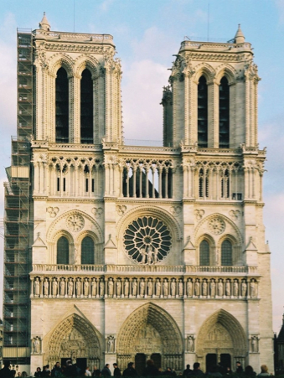 | 45. 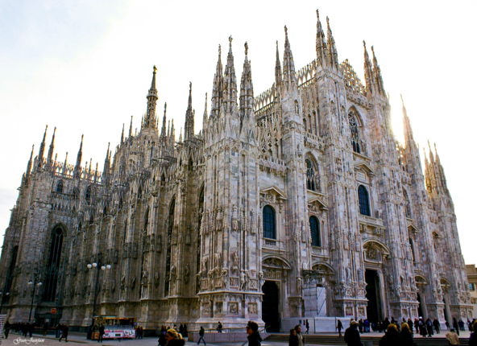
46. 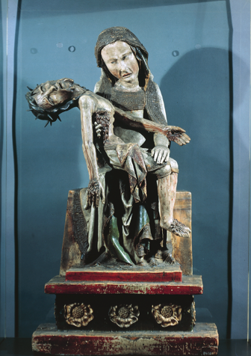 | 47. 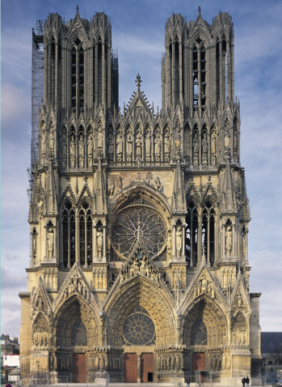
48. 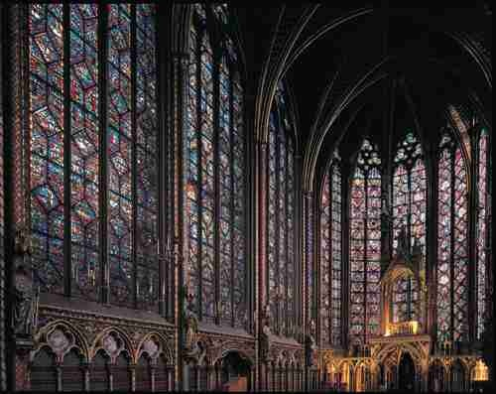 | 49. 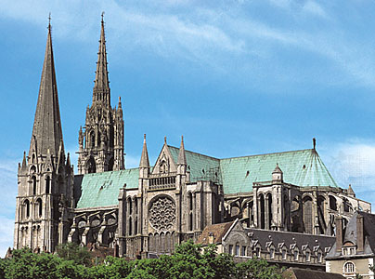

44. a. __________________________________ b. ________________________________________ c. ____________________________

45. a. __________________________________ b. ________________________________________ c. ____________________________

46. a. __________________________________ b. ________________________________________ c. ____________________________

47. a. __________________________________ b. ________________________________________ c. ____________________________

48. a. __________________________________ b. ________________________________________ c. ____________________________

49. a. __________________________________ b. ________________________________________ c. ____________________________

50. Short Answer: Discuss the image of the Virgin Mary presented in Virgin of Paris and the Rottgen Pieta. How are they a product of its time?
___________________________________________________________________________________________________________________________
___________________________________________________________________________________________________________________________
___________________________________________________________________________________________________________________________
___________________________________________________________________________________________________________________________
___________________________________________________________________________________________________________________________
___________________________________________________________________________________________________________________________
___________________________________________________________________________________________________________________________
___________________________________________________________________________________________________________________________
___________________________________________________________________________________________________________________________
___________________________________________________________________________________________________________________________
___________________________________________________________________________________________________________________________
___________________________________________________________________________________________________________________________
__________________________________________________________________________________________________________________________________________________________________________________________________________________________________________________________
___________________________________________________________________________________________________________________________
___________________________________________________________________________________________________________________________

