Art History Quiz: Multiple Choice Ms. Park Early Renaissance Name__________________________________________
Date____________ Period______ Score /72 pts

1. Time period for 539 BCE: _____________________________
2. Date for the Hellenistic Greek time period: _____________________________
3. Date for the Roman Imperial time period: _____________________________
4. Date for the Sumerian time period: _____________________________
5. Time period for 800: _____________________________
6. Date for the High Gothic time period: _____________________________
7. Date for the Romanesque time period: _____________________________
8. Date for the 14th century Early Renaissance: _____________________________
9. Date for the 15th century Early Renaissance: _____________________________
10. Which of the following was a revived interest during the Renaissance?
a. Hiberno-Saxon manuscripts b. Classical culture
c. Islamic culture d. Platonic interpretation of Christianity

11. The most devastating natural disaster in Europe during the late 1300s was which of the following?
a. mad cow disease b. the collapse of the linen market
c. the failure of the Medici banks d. the Black Death

12. Giotto’s Enthroned Madonna reflected the new trend toward naturalism and classical modeling of the figures. Which of the
following describes this new trend?
a. The Virgin is slender and fragile b. Her cloak is heavily patterned with gold threads
b. The Virgin is solid and has mass d. The figures float as if in the spiritual realm

13. What is a campanile?
a. a small chapel b. a baptistery
c. a detached bell tower d. a rounded transept

14. How did Masaccio create a sense of bulk for his figures in the Holy Trinity?
a. through modeling with a specific light source
b. through modeling with a flat neutral light
c. through modeling with a bad light source
d. through modeling

15. Which of the following best describes the values of humanism?
a. humanism was the adoration of the human form
b. humanism was the focus on the effects of one’s actions in relation to other people
c. humanism was the focus on achievement on Earth rather than preparation for the afterlife
d. humanism was the assumption that humans could reach godlike status

16. The development of linear perspective is generally credited to
a. Donatello b. Brunelleschi c. Uccello d. Ghiberti

17. Which of the following was the most prominent patron of 15th century Florentine art?
a. Medici family b. Pazzi family c. Riccardi family d. Parchezzi family

18. The statue of David is a classical representations of the male figure in all of the following ways EXCEPT through the
a. artist’s rendering of the subject as a free-standing sculpture
b. miniature scale of the figure
c. subject’s youth and near-complete nudity
d. use of bronze as a medium

19. Before the creation of Donatello’s David, nude sculptures were not executed because
a. they represented the pagan world of mythological gods
b. artists were influenced by a general ban on images in Jewish art
c. they showed man in a primitive and bestial state
d. they were not suitable for churches

20. Fra Filippo Lippi’s Madonna and Child with Two Angels reflects the Renaissance’s attitude toward a more
a. ethereal and heavenly vision of Mary and Jesus
b. formal and forbidding image of divine figures
c. human and approachable interpretation of heavenly figures
d. pagan and mythological approach to Christian imagery

21. In 1401 an important competition was held to determine the design of the Bapistery doors for the Cathedral of Florence (The
Gates of Paradise). Even at the early date Renaissance traits were evident. Which of the following is one of those traits?
a. adherence to the 14th century frame b. a new pictorial illusionism
c. maintaining artist anonymity d. humility in civic pride

22. Which of the following is true?
a. Italian artists preferred to use oil on canvas during the 14th century
b. artists preferred to compose paintings in a pyramidal composition
c. artists focused on an idealized human depiction inspired by the ancient Greeks
d. most artists were hired by the Medici family to paint devotional scenes

23. Of the choices given, which word describes Botticelli’s Birth of Venus best?
a. curvilinear b. geometric
c. asymmetrical d. volumetric

24. Humanists of the early Renaissance were most closely associated with which endeavor?
a. studying Greek and Roman texts b. interpreting the Gospels
c. studying the Old Testament d. translating the New testament from Hebrew to Latin

25. Which of the following does NOT apply to 15th century Florentine architecture?
a. it relied on intuition rather than mathematics
b. it represented a conscious revival development of ancient Greek and Roman texts
c. it eschewed the complex proportional systems and irregular profiles of medieval buildings
d. it placed emphasis on symmetry, proportion, geometry, and regularity of parts

26. Which of the following was a technique introduced in the 15th century Florentine art that utilizes value?
a. foreshortening b. use of realistic proportions
c. chiaroscuro d. all of these answers

27. In Holy Trinity, there is a coffered barrel-vault reminiscent of which of the following?
a. The Baths of Diocletian b. the Pantheon
c. a Roman triumphal arch d. the Basilica of Constantine

28. The lilies in the vase in between the Angel Gabriel and Mary were symbolic of Mary’s
a. kindness b. piety c. virginity d. marital status

29. Ghiberti’s competition panels for the Florence _________ doors are sometimes see as the beginning of the Renaissance.
a. Baptistery b. Cathedral c. campanile d. dome

30. Which of the following is NOT true of Brunelleschi’s dome?
a. Brunelleschi created ribs that were supported horizontally that helped to bear the weight of the dome.
b. The bricks are hollow and therefore counter the downward and outward thrust of the dome.
c. To help manage the weight of the dome, Brunelleschi created a hollow dome with inner and outer shells.
d. The bricks that make up the dome were placed in locking pattern that helped to secure them in place.

31. The Pazzi Chapel shows careful attention to geometry in its plan and construction which echoes the great buildings of
a. the ancient Etruscans b. ancient Egypt
c. the ancient Near East d. ancient Rome

32. (10 points) This image is from the Arena Chapel in Padua, Italy called Lamentation by Giotto, dated around 1305.

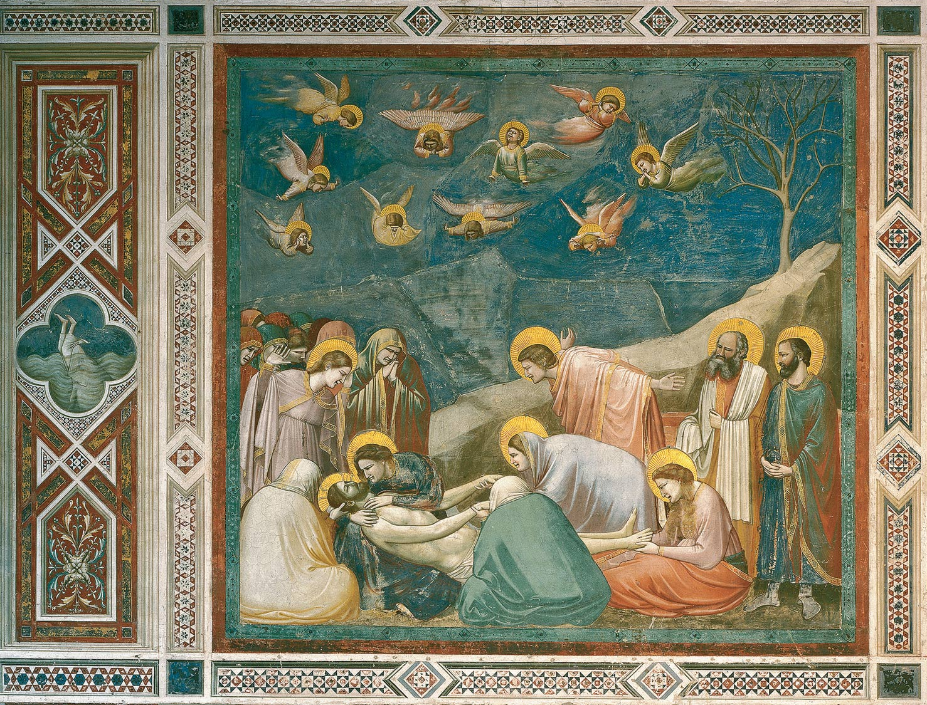

What is the scene in the margin on left?
How does this marginal scene represent a parallel to the main scene?
What specific ways does the main scene of the Lamentation show how Giotto used revolutionary techniques for the 14th century.

______________________________________________________________________________________________________
______________________________________________________________________________________________________
______________________________________________________________________________________________________
______________________________________________________________________________________________________
______________________________________________________________________________________________________
______________________________________________________________________________________________________
______________________________________________________________________________________________________
______________________________________________________________________________________________________
______________________________________________________________________________________________________
______________________________________________________________________________________________________
______________________________________________________________________________________________________
______________________________________________________________________________________________________
______________________________________________________________________________________________________
______________________________________________________________________________________________________
______________________________________________________________________________________________________

Art History Quiz: Artist/Title Identification Ms. Park Early Renaissance

Name_______________________________________ Score ______/ 28 pts

Artist Title
(1 pt) (1 pt)
- ________________________________________ ___________________________________________________
- ________________________________________ ___________________________________________________
- ________________________________________ ___________________________________________________
- ________________________________________ ___________________________________________________
- ________________________________________ ___________________________________________________
- ________________________________________ ___________________________________________________
- ________________________________________ ___________________________________________________
- ________________________________________ ___________________________________________________
- ________________________________________ ___________________________________________________
- ________________________________________ ___________________________________________________
- ________________________________________ ___________________________________________________
- ________________________________________ ___________________________________________________
- ________________________________________ ___________________________________________________
- ________________________________________ ___________________________________________________

