Art History Ms. Park Late Antiquity and Byzantine

Name__________________________ Period______

Date_______________ Score __________/ 82 pts

1. Time period for 3000 BCE: _______________________________________
2. Approximate date for the Hellenistic time period: ___________________
3. Approximate date for the Persian time period: ____________________
4. Time period for 250 CE: _________________________________ AND _______________________________
5. Approximate date for the Egyptian Old Kingdom: ___________________
6. Approximate date for the Egyptian New Kingdom: ____________________
7. Approximate date for the Classic Greek time period: ____________________
8. Time period for 350 BCE: _____________________________________________
9. Time period for 550 BCE: _________________________________ AND _______________________________

10. What is the earliest dateable period for Christian art?
a. 5th century b. 1st century c. 3rd century d. 6th century

11. A dome can be supported by
a. a cylindrical drum b. pendentives
c. squinches d. All these answers are correct.

12. Which is LEAST likely to be represented in a Byzantine mosaic?
a. frontality b. contrapposto
c. outlined figures d. repeated poses
e. flattened forms e. None of these

13. Which feature of Hagia Sophia was NOT part of the original design?
a. the dome b. the pendentives
c. the minarets d. the narthex

14. How are the Roman and Byzantine Empire related?
a. The Byzantine Empire was established after the fall of the Roman Empire
b. The Byzantine Empire is the Western Roman Empire after the fall of the Eastern Roman Empire
c. The Byzantine Empire is the same as the Roman Empire
d. The Byzantine Empires is the Eastern Roman Empire after the fall of the Western Roman Empire

15. Where did the first images and iconography of Christian art appear?
a. converted Roman temples b. renovated basilicas
c. catacombs d. sarcophagi

16. The Passion are the stories of
a. Christ’s birth b. Christ’s relationship with the Virgin Mary
b. Christ’s ministry work d. Christ’s death

17. Which of the following is an example of a basilica plan?
a. Santa Costanza b. Old St. Peter’s c. San Vitale d. St. Callixtus’s

18. Which best defines an icon?
a. an image on a wood panel b. an image of Christ
c. any religious image d. a purely devotional image

19. What does light represent in early Christian churches?
a. Christ’s ultimate sacrifice b. she Virgin Mary as “Theotokos”
c. the Manifestation of God d. martyred saints

20. Mosaics are created with individual tiles called
a. tesserae b. glass
c. theotokos c. cubiculum

21. Loculi are
a. a insect considered to be a pest
b. a large room in catacombs where sarcophagi are placed
c. individual carved spaces to place bodies in catacombs
d. figures in a praising stance

22. The mosaics of Justinian and Theodora have been placed in San Vitale
a. to commemorate a state visit by the Emperor and Empress
b. as a thank you for helping to construct the building
c. as stand-in to symbolize their semi-divine statues as participants in the Mass
d. because they were declared saints after their deaths

23. Construction of buildings like Santa Sabina relies on construction principles learned in the
a. Basilica such as the Forum of Trajan b. Pantheon
c. Colosseum d. Hagia Sophia

24. The Good Shepherd is an image in the Early Christian catacombs that has its origins in the Bible, but pictorially the
images are inspired by
a. Greek images of shepherding
b. Roman belief that shepherds are superior
c. Cultivation of extensively planned gardens
d. prehistoric cave paintings

Label the following common Christian symbols
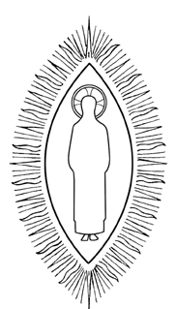  25. ____________________________ | 26. ____________________________ | 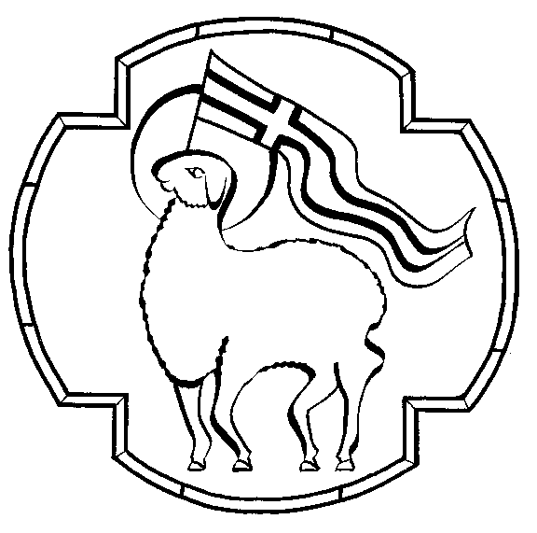  27. ____________________________
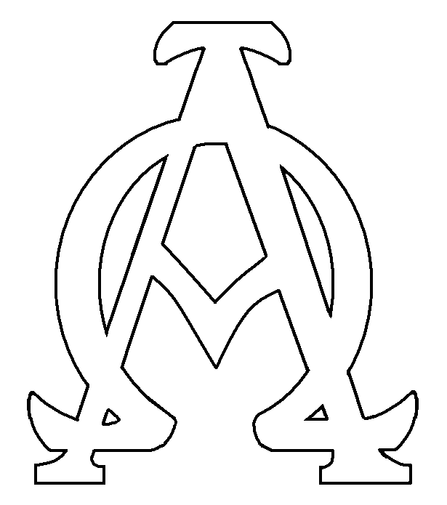  28. ____________________________ | 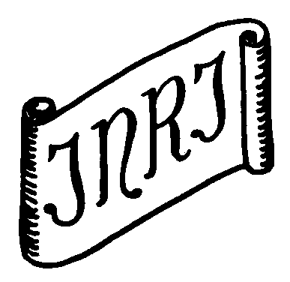  29. ____________________________ | 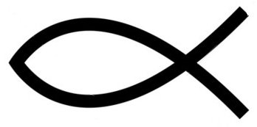  30.  ____________________________
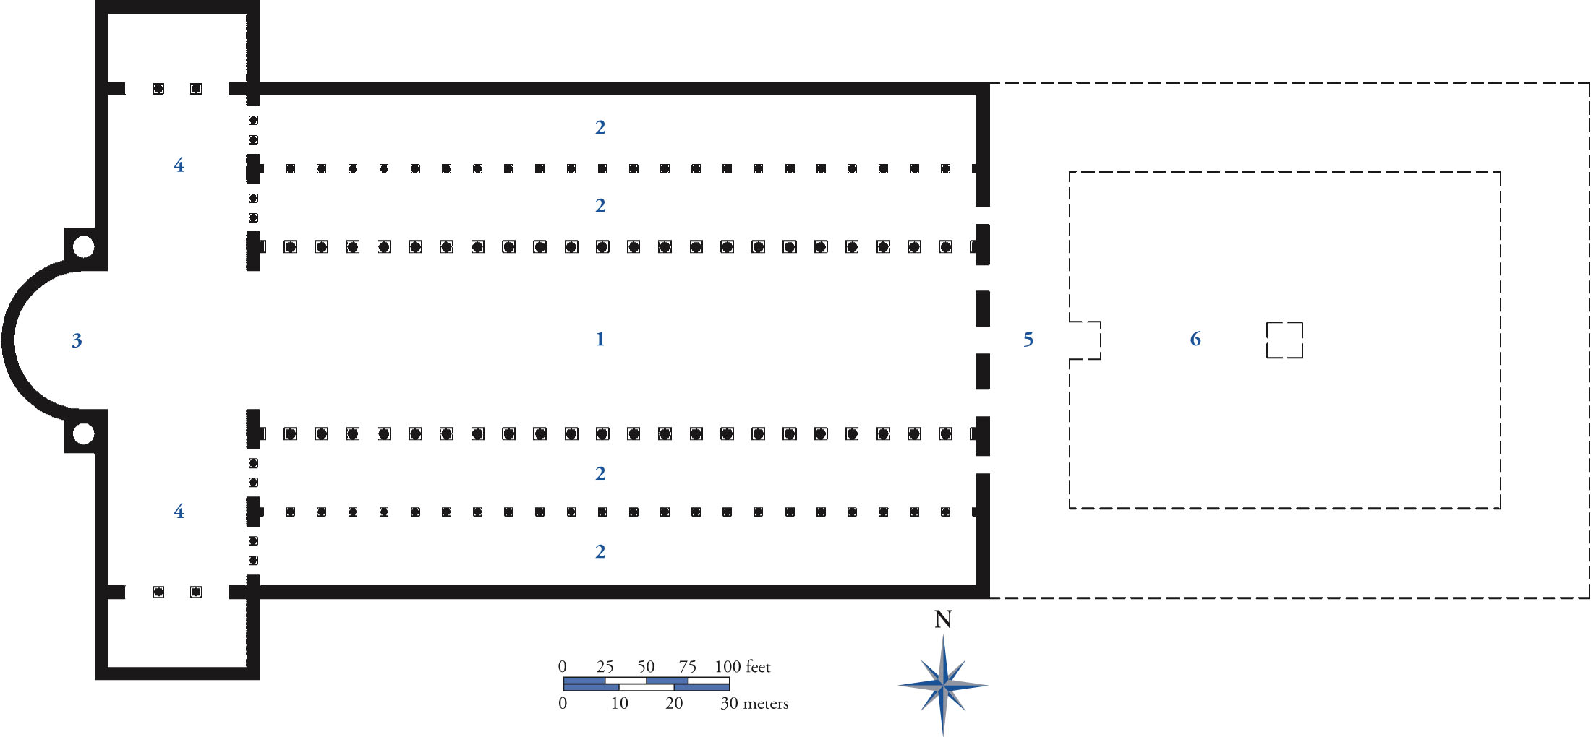

Label the diagram: 31. (1) ________________________________ 32. (2) ________________________________
33. (3) ________________________________ 34. (4) ________________________________
35. (5)________________________________ 36. (6) ________________________________

37. The images below show the interior and the ground plan of the church of Santa Sabina in Rome. What are the principal architectural elements of this design? Describe which elements of the Christian design were adapted from non-Christian sources. Analyze how the design of the building is meant to accommodate the needs of the Christian ceremony.






