Art History Quiz Ms. Park High Renaissance and Mannerism Name__________________________________________
Date___________ Period______ Score _______ / 72 pts
1. Date of the Sumerian period: ______________________
2. Date of the Greek geometric time period: ______________________
3. Date for the Late Gothic time period: ______________________
4. Date of the Ottonian period: ______________________
5. Date of the Imperial Rome time period: ______________________
6. Century for the beginning of Islam (when Muhammad started receiving revelations): ___________________
7. Time period for 5,000BCE: _____________________________
8. Time period for 350 BCE: _____________________________
9. Time period for 1100: _____________________________
10. Time period for 1500 BCE: _____________________________

11. How has Michelangelo portrayed David?
a. At the moment of victory b. With stern watchfulness before battle
c. By celebrating the defeat of Goliath d. By watching Goliath die

12. Michelangelo’s fascination with the human body was a lifelong pursuit. In his statue of David he presented a perfect body with an
attuned mind, prepared and ready for action. Which of the following descriptions of this work would support this statement?
a. It is a combination of Greek perfection and psychological insight.
b. It is a combination of Hellenistic excess and restrained emotion.
c. It is a combination of athletic tension and emotional excess.
d. It is a combination of athletic tension and psychological insight.

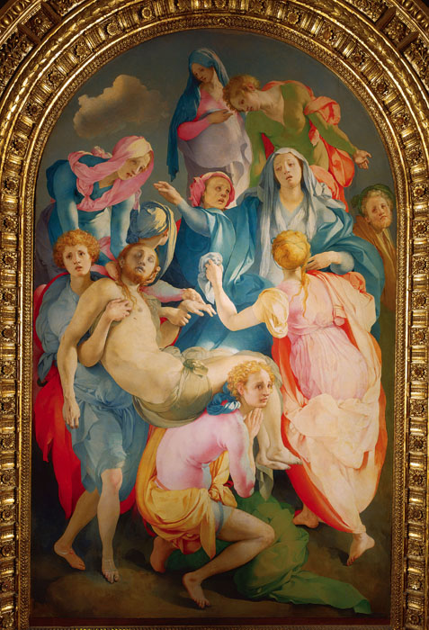

13. Refer to Figure A. This type of painting is a departure from High Renaissance painting in that it
a. relies on symbolism to convey its meaning
b. has exaggerated and elongated figures
c. is painted with quick and visible brushstrokes
d. is meant for private viewing rather than public display

14. Refer to Figure A. Paintings from this period are often seen as all of the following EXCEPT
a. satiric and filled with contemporary commentary
b. coded in layers of meaning defying one simple explanation
c. intentionally confusing in order to create a sense of imbalance
d. highly intellectual and deliberately complex

Figure A

15. Da Vinci’s Last Supper provided a general inspiration for Raphael’s School of Athens. This can be seen particularly in the use of
a. strict symmetry, which adds balance to the composition
b. self-portraits in discreet locations
c. linear perspective, which creates a unified architectural framework
d. contemporary faces placed on people from the past

16. Which of the following is not true of Da Vinci’s Last Supper?
a. Christ subtly reaches for the bread and wine, anticipating the first communion
b. Da Vinci includes all of the traditional symbols of the divine in the painting
c. At the Last Supper, Christ informs the apostles that one of them will betray him. The apostles each react individually. d. Judas holds his bag of silver, which he was paid to betray Christ.

17. In the Last Supper, the curved pediment above the head of Christ represents which of the following?
a. The Parthenon b. pagan Rome
c. a halo d. mere ornamentation

18. The Sistine Chapel ceiling illustrates which stories?
a. the first chapters of Genesis b. the stories of the New Testament
c. the history of prophets d. the chronology of the Early Christian Church in Rome

19. Which sculptor believed that the artist must proceed by first finding the idea- the image- locked in the stone and then release it by
chipping away the stone?
a. Leonardo da Vinci b. Michelangelo
c. Raphael d. Donatello

20. Which of the following was the primary church for the Jesuits in Rome?
a. St. Peter’s b. Il Gesu
c. San Giorgio Maggiore d. Santa Maria Maggiore

21. Which of the following was one of the favorite compositional devices of painters of the High Renaissance?
a. a flat triangle b. a trapezoid
c. a pyramid d. an oval

22. The painterly technique sfumato can be identified in of the following artworks?
a. Michelangelo’s David d. Bronzino’s Venus, Cupid, Folly, and Time
c. Raphael’s School of Athens d. Da Vinci’s Mona Lisa

23. The innovative techniques that make Da Vinci’s work unique include all of the following EXCEPT
a. his use of subtle gradation of tone b. his innovative use of the human form in figurative composition
c. his realistic depiction of landscape d. his use of sfumato

24. Raphael’s School of Athens fresco is focused on which two historical figures?
a. Da Vinci and Michelangelo b. Plato and Aristotle
b. Plato and Socrates d. Contemporary Pope Julius II and a de Medici family member

25. Which of the following is NOT true of Raphael’s School of Athens?
a. The scene is a fabrication, showing Greek philosophers who lived at different times together at a single gathering.
b. The statues on either side of the central figures represent Catholicism and Paganism
c. The architecture in this painting is more Roman than Greek.
d. The two central figures in the painting are ancient philosophers

26. Which of the following BEST completes the description for Mannerism?
a. unconnected figures b. physical power
c. aloof subject gazes d. contrapposto

27. The term terribilita is most often associated with which artist?
a. Leonardo da Vinci b. Michelangelo
c. Raphael d. Donatello

28. Which of the following is NOT true of Michelangelo’s ceiling for the Sistine Chapel?
a. The architectural framing that we see surrounding the central scenes is the only real element on the ceiling, the remainder is paint.
b. The outer scenes show the prophets and sibyls that foretell the coming of Christ.
c. The scenes from the central panel show the Temptation of Adam and Eve and their Expulsion from Eden indicating the
need for Christ’s sacrifice in the New Testament.
d. The scenes along the central panel represent episodes from Genesis in the Old Testament.

29. Mannerist artists were interested in creating
a. elegant, elongated bodies and looked to art for inspiration (Renaissance artists looked primarily to the natural world.)
b. elegant but flattened figures that recalled medieval art.
c. elegant settings that overwhelmed the figures.
d. elegant, realistic bodies set in realistic natural settings.

30. How are Mannerist characteristics shown in Michelangelo’s Last Judgment?
a. having references to Dante’s Inferno
b. distortions of the body, elongations, and crowded figures
c. having four broad horizontal bands that act as a unifying element

31. What trend of Mannerism is best exemplified by Madonna with the Long Neck?
a. Intentionally disproportionate figures b. The mixture of various elements of Classical architecture
c. A non-naturalistic color palate d. All of these

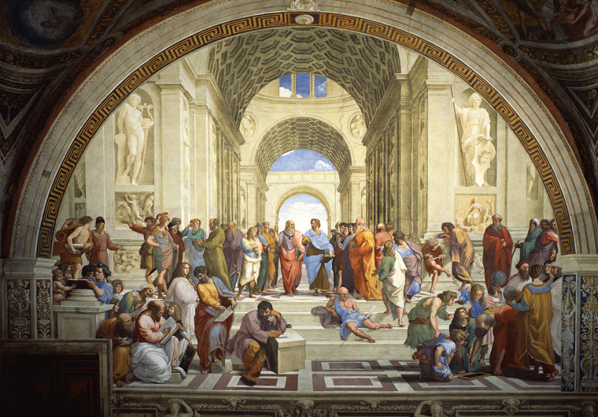
32. 10 points
a. Properly identify the artwork, artist, and patron.
b. In what ways do the style and subject matter of the painting reflect the interest of its patron?
c. How does this painting reflect the ideals of the High Renaissance?
d. What connections to the past are being made with this work?

________________________________________________________________________________________________________________________________________________________________________________________________________________
_________________________________________________________________________________________________________________________________________________________________________________________________________________________________________________________________________________________________________________________________________________________________________________________________________________________________________________________________________________________________________________________________________________________________________________________________________________________________________________________________________________________________________________________________________________________________________________________________________________________________________________________________________________________________________________________________________________________________________________________________________________________________________________________________________________________________________________________________________________________________________________________________________________________________________________________________________________________________________________________________________________________________________________________________________________________________________________________________________________________________________________________________________________________________________________________________________________________________________________________________________________________________________________________________________________________________________________________________________________________________________________________________________________________________________________________________________________________________________________________________________________________________________________________________________________________________________________
_________________________________________________________________________________________________________________________________________________________________________________________________________________________________________________________________________________________________________________________________

