Art History Quiz Ms. Park
Islamic Art and Architecture Name__________________________ Period______
Date_______________ Score __________/ 130pts.

1. Date for the Paleolithic time period: ______________________
2. Date for the Greek Late Classical time period: ______________________
3. Date for the Sumerian (Sumer) time period: ______________________
4. Date for the Persian time period: ______________________
5. Date for high Gothic architecture: _____________________
6. Time period of 5,000BCE: ___________________________________
7. Date for the Roman Republic time period: ____________________
8. Date for the Egyptian time period of the Old Kingdom: ______________________
9. Time period for 1100: ___________________________________
10. Date for the Egyptian time period of the New Kingdom: ______________________
11. Time period for 550: ___________________________________
12. Date for late Gothic architecture: _____________________
13. Date for the Egyptian time period known as the Amarna: ______________________
14. Date for the Greek Archaic time period: ______________________
15. Time period for 1900BCE: ___________________________________
16. Date for the Greek Classical time period: ______________________
17. Date for the Roman Imperial time period: _____________________
18. Time period for 800: ___________________________________
19. Time period for 480 BCE: ___________________________________
20. Date for the Ottonian time period: _____________________
21. Time period for 1140: ___________________________________
22. Date for the Greek Hellenistic time period: ______________________
23. In what century did the prophet Muhammad begin receiving revelations? _______________

24. The decoration on the basin called the Baptistere/basin de St. Louis is noted for its use of
a. calligraphy b. contrapposto
c. horror vacui d. tessellation

25. Though originally intended to wash the hands during official ceremonies, what was the later function of the
Baptistere/basin de St. Louis?
a. the baptism of infants in the French royal household b. coronation rituals of royalty
c. retelling mythological stories of the ancient past d. collecting the tears of royals

26. The importance of the Bapistere de St. Louis is alluded to in the
a. rich material used to create it b. use of lions and peacocks as royal symbols
c. depiction of the royal family and their entourage d. purple color which symbolized royalty

27. How has the Great Mosque at Cordoba been altered by Christians after the reconquest of Spain?
a. the interior arches were taken down to make a cast unified space
b. the mihrab was destroyed and an altar was placed in its stead
c. the central interior was reroofed used European vaulting techniques
d. the building was turned into a church and then back in to mosque

28. The architect of the Great Mosque at Cordoba borrowed the horseshoe arch from the _______ and was widely adapted
into Western Islamic architecture.
a. Ostrogoths b. Romans
c. Vikings d. Visigoths

29. Which of the following is NOT a feature of the Great Mosque at Cordoba?
a. dome b. mihrab c. minarets
d. cathedral e. cella f. hypostyle hall

30. Which one of the following structures was created under Shah Jahan?
a. The Red Fort b. The Taj Mahal
b. The Kaaba d. The Dome of the Rock

31. The depiction of the human figure, normally considered idolatry and forbidden under Islamic law, was much less
constrained in miniature paintings. Why is this?
a. Miniatures were an art of the secular court, and therefore were not generally seen in public
b. Miniatures were considered holy in and of themselves, thereby allowing the depiction of figures
c. The figures found in miniatures always conveyed religious piety and worship
d. The figures found in miniatures were distorted and abstract, so as not to promote idolatry

32. A pyxis is used for holding
a. jewelry b. relics
c. cosmetics d. holy water

33. On the Pyxis of Al-Mughira, the medallion showing the lion attacking a bull is a symbol of Umayyad
a. military strength b. religious authority
c. wealth d. legitimacy

34. The Pyxis of Al-Mughira is created from
a. white marble b. abalone shell
c. ceramic d. ivory

35. The Ardabil Carpet and its twin was placed in a
a. shrine b. mosque
c. palace d. mausoleum

36. The luxury carpets from Iran are created using Persian knots. The Ardabil carpet has approximately
a. 500,000 knots b. 1 million knots
c. 25 million knots d. 100 million dollars…..I mean….knots!

37. The Book of Kings is considered a literary masterpiece. What type of literature is the Book of Kings and what does it
describe?
a. a Persian sonnet of lost loves b. an epic poem containing Persian history
c. documentation of the first Persian king d. a set of written rules for the royal court to abide by

38. According to Muslims, who were the original builders of the original Kaaba?
a. Noah and his wife b. Moses and his sons
c. Abraham and his son d. Muhammad and the Angel Gabriel

39. The holiest shrine in Islam that all Muslims must try to make a pilgrimage to is
a. the Kaaba b. The Great Mosque of Selim II
c. Dome of the Rock d. The Prophet’s house in Medina

40. What does the fountain in the Court of Lions at the Alhambra symbolize?
a. strength and sovereignty c. the emblem of the Nasrid Sultans
b. The Islamic secret passage way to Narnia d. culture of keeping foreign exotic pets

41. The Alhambra was a
a. mosque and religious center b. palace and fortress
c. shrine and tomb d. workshops and marketplace

42. The Alhambra was built for which Dynasty?
a. Umyyads b. Nasrids
c. Abbasids d. Maqsud of Kashan

43. Which group is most famous for their architecture?
a. Umyyads b. Abbasids
c. Persians c. Ottomans

44. At the center of the Dome of the Rock is a large rock which is believed to be the location where ________.
a. Jesus was born b. The Qur’an was written
c. Muhammad was born d. Muhammad ascended into heaven

45. Which is not true of the Dome of the Rock
a. The use of mosaics reflects an artistic tie to Late Antiquity
b. The shape and dome of the building recall the Pantheon in Rome
c. The Rock is enclosed by two ambulatories and an octagonal exterior wall
d. The mosaics in the Dome of the Rock contain no human figures or animals.

46. The Dome of the Rock
a. the beginning of Islam b. the rock n’ rolls days of the 80s
c. in the Abrahamic days d. 17th c.

47. The word Islam means
a. “Love thyself” b. “Submission to Allah”
c. “Only one God” d. “5 Pillars of Faith”

48. The holy text of Islam, the Qur’an, is written in Kufic. Why is the text so highly regarded?
a. It is the revelations of Muhammad from Allah b. It is an extension of the 10 Commandments
c. It is so labor intensive that only the elite could create it. d. It is made up of hadiths directly from Allah

49. Who is the founder of Islam?
a. Abraham b. Jesus
c. Muhammad d. the Angel Gabriel

50. The _________ is a niche in the ___________ wall that indicates the direction of Mecca.
a. muqarnas; mihrab b. qibla; mihrab
c. mihrab; qibla d. iwan; minaret

51. Islamic art refers exclusively to religious artworks.
a. true b. false

52. An example of an iwan can found at
a. The Great Mosque of Selim iI b. The Great Mosque at Cordoba
c. The Great Mosque at Isfahan d. The Dome of the Rock

53. The materials used in the folio Court of Guyumar suggest
a. that the text was religious b. that the text was instructional
c. the text was commissioned by a wealthy patron d. that the text was commissioned by an imam

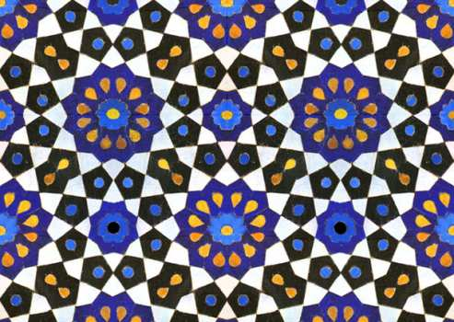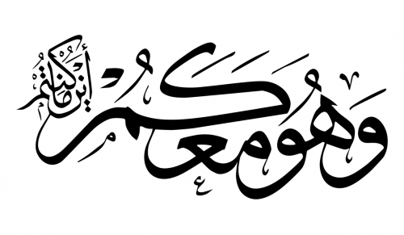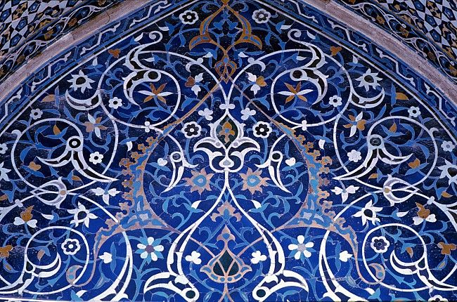

54. _________________________ 55. ___________________________ 56. _____________________________

57. (Fill in the blank.) The images in questions 52-54 are types of _________________________ imagery, meaning they
are non-figural art.

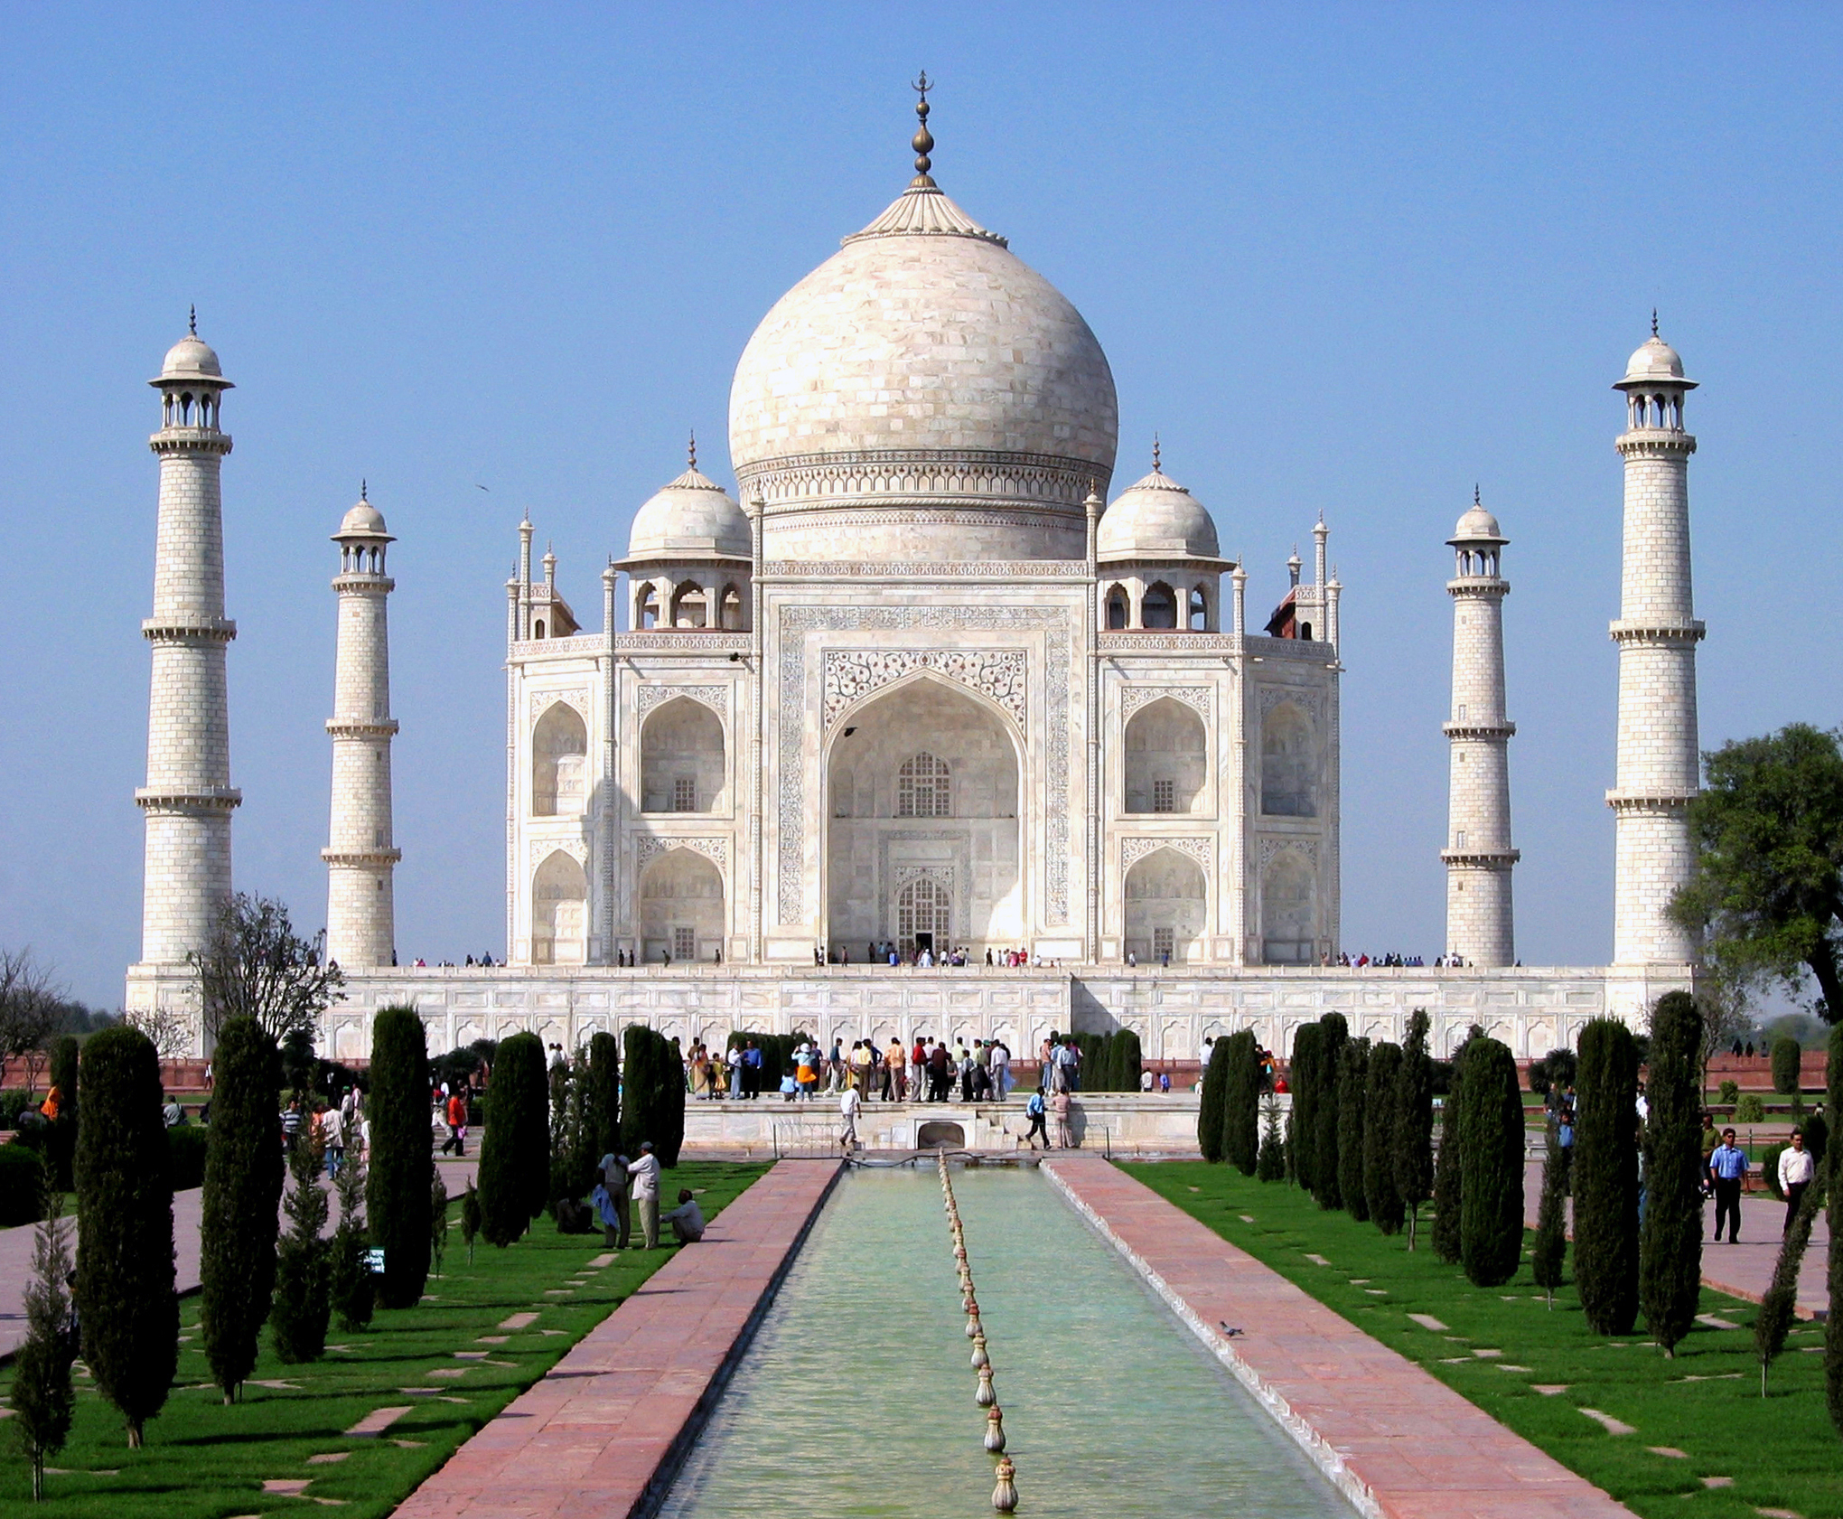  58. Identify the FULL title of the architecture  59. Identify the patron  ________________________________  60. Why was this building created?  ________________________________  ________________________________  ________________________________  ________________________________  ________________________________ | 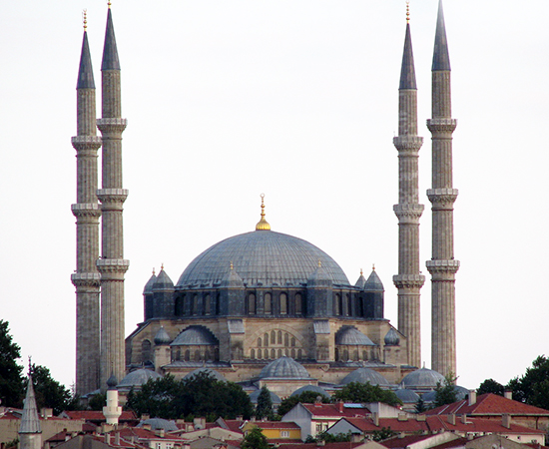  61. Identify the FULL title of the architecture  62. Identify the architect  _______________________________  63. Why did the Ottomans build such a grand mosque?  _______________________________  _______________________________  _______________________________  _______________________________  _______________________________ | 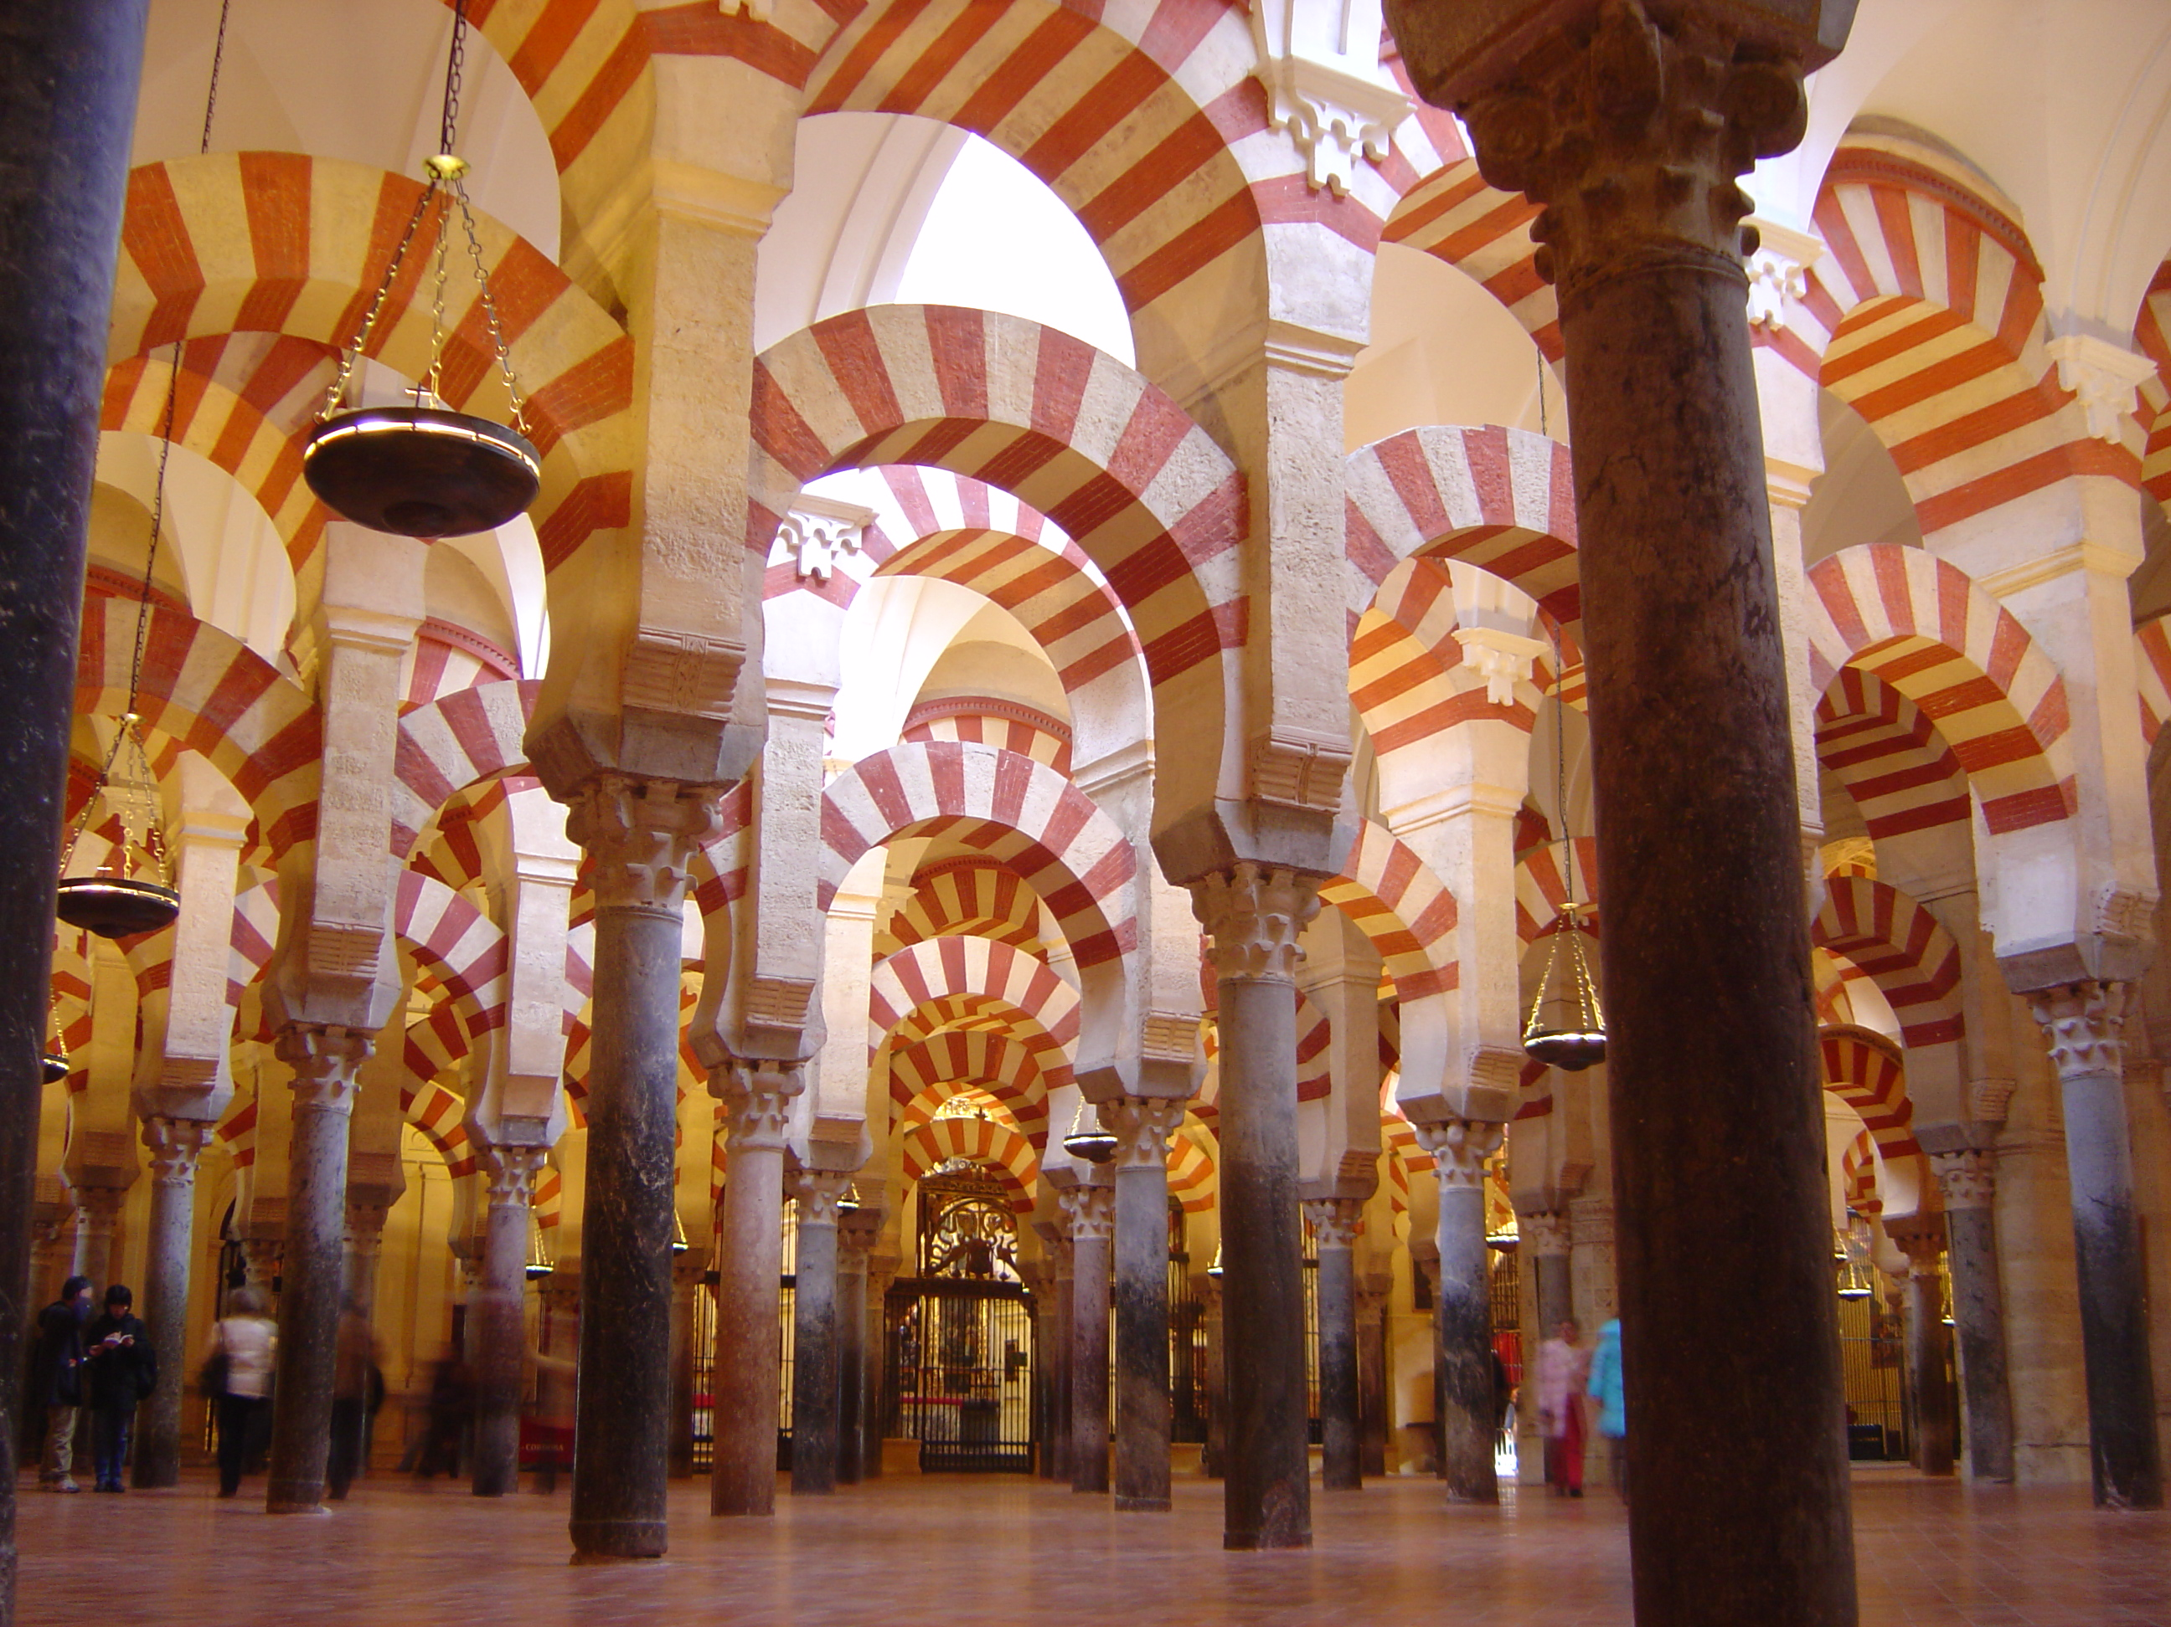  64. Identify the FULL title of the architecture  ________________________________  65. What type of hall is this?  _______________________________

