Art History Quiz Ms. Park Pre-Modernism

Name ___________________________________________
Date ___________________ Score _______ / 58 pts

1. 1886 ____________________________________________ 2. 1730___________________________________________
3. 1900 ____________________________________________ 4. 1800____________________________________________
5. 1874 ___________________________________________ 6. 1850 ___________________________________________
7. 1830 ___________________________________________ 8. 1837 ___________________________________________
9. 1890 ___________________________________________ 10. 1650 __________________________________________

11. The late 19th century European painting had a fascination for all the following except
a. trains, canals, and other forms of the modern transportation
b. light atmospheric effects achieved by short brushstrokes
c. still lifes and landscapes
d. historical and religious subjects done on commission

12. Painters achieved fame in the 19th century by having their works
a. realize success at the Salon of Paris
b. photographed for posterity
c. enter royal collections
d. shipped to eager buyers in non-Western countries

13. What technique did Manet use that forged the way for the Impressionists who followed him?
a. simplification of details b. abbreviated, sketch-like style
c. loose brush strokes d. all of these answers

14. Manet’s Olympia horrified contemporary critics as well as the public because
a. the central figure was a prostitute, which was new in art history
b. the inclusion of a black woman was bold and experimental
c. it relied on the Renaissance view of a formal composition and that was deemed outdated
d. it depicted the main figure as shameless and defiant in her role

15. Manet modernized the tradition of the female nude by rejecting academic conventions of ___. (choose 2)
a. chiaroscuro, modeling, in the figure’s form
b. a color for the background of the image
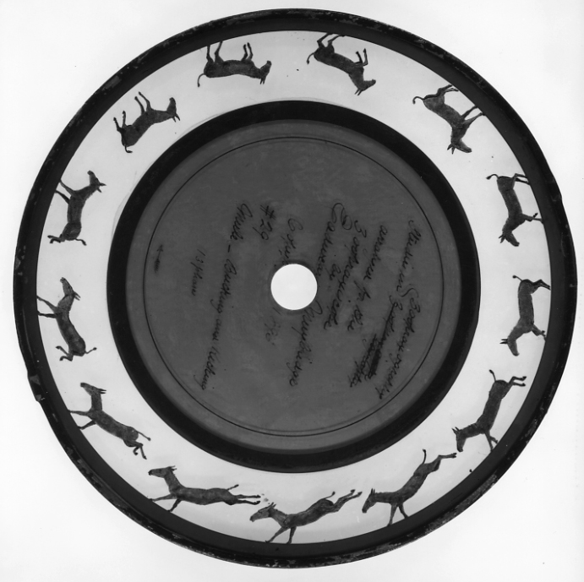
c. the relationship of the nude to the viewer
d. the horizontal composition of the image

16. Eadward Muybridge’s experiments using the zoopraxiscope (Figure A to the right) enabled him to
a. draw onto a negative to create special effects
b. freeze the action of a fast-moving object
c. introduce color for the first time in a world of black and white photography
d. make multiple copies from a single negative.
Figure A
17. All of the following were interests of the Impressionist painters EXCEPT
a. rendering the effects of natural light
b. recording a moment in time
c. suggesting mood or emotion with bright colors
d. depicting scenes of modern life

18. The term impressionism came from the title of which artist’s landscape painting
a. Monet b. Cezanne
c. Cassatt d. Manet

19. Post-Impressionist artists differed from the Impressionist a generation earlier by rejecting the Impressionist use
a. everyday people and situations in their work b. paintings in a series
c. the transitory effect of changing atmospheric conditions d. solid massing of forms

20. Which of the following statements regarding Impressionism and Post-Impressionism is true?

a. Both used unnatural colors in their compositions.

b. Both styles used vivid colors and distinctive brush strokes in their work.

c. Impressionism focused on abstraction, while Post-Impressionism favored real-life subject matter.

d. Post-Impressionism reject the thick application of paint characteristic of Impressionism.

21. In Klimt’s The Kiss, the artist has captured the extravagance and opulence of the period. How was this painting a visual manifestation of the fin de siècle (“end of the century”)?

a. It captured an opulence conveyed by he formalism of the subject matter.

b. It captured an opulence conveyed by the linearity of the form.

c. It captured an opulence conveyed by patterns and sensuous image.

d. It captured an opulence conveyed by soft tonalities of the image.

22. Which of the following ideas did Vincent van Gogh attempt to communicate in his Starry Night?
a. Darkness of night
b. birth of a galaxy
c. vastness of the universe
d. myopia of humanity

23. What is true about van Gogh’s Starry Night?
a. Colors, despite dynamic expression of brushstrokes, evokes a depression.
b. The Cyprus tree is a metaphor for death.
c. Starry Night was painted early in his career.
d. The artist was so upset after he couldn’t sell Starry Night, he cut off part of his ear and sent it to his brother

24. Cassatt’s style of work owes much to which of the following?
a. Giorgione
b. Japanese prints
c. Leonardo’s sketchbooks
d. Michelangelo

25. Extreme subjectivity and the need to see through reality to a deeper reality (and into the inner psyche) was most typical of which of the following styles?

a. Impressionists

b. Symbolists

c. Neoclassicists

d. Realists

26. Which of the following statements regarding Art Nouveau is FALSE?

a. The style was most popular from the 1890s – about 1914.

b. Art Nouveau is influenced by organic motifs.

c. It is considered a philosophy of interior decoration.

d. It is an art form found exclusively in France.

27. Klimt’s use of gold in The Kiss recalls

a. Ancient Near Eastern sculpture

b. Byzantine mosaics and religious icons

c. Egyptian funerary objects

d. non-Western decorative arts

28. The Burghers of Calais expresses the emotions of despair, defiance, and resignation. Rodin has captured these emotions in the

roughly textured surfaces of the figures. He wanted the citizens of Calais to experience this heroic episode in their city’s history.

Which of the following was a device Rodin used to create the pathos of this heroism?

a. no traditional high base placed the monument eye-to-eye and closer to the viewers

b. small scale of images allows viewers a more intimate experience of this great moment

c. carefully placing this monument in the city’s center emphasized the heroism

d. creating slender and elegant figures captured the historical moment

29. What is the most important feature of Sullivan’s Carson Pirie Scott Building that distinguishes it from earlier structures?

a. the elimination of revival decorative elements

b. its use of cast iron structural supports
c. his use of modular construction.
d. the function dictates the form and overall look of the building

